MEDIEVAL AND ROMANESQUE PAVIA
(11th - 13th centuries)
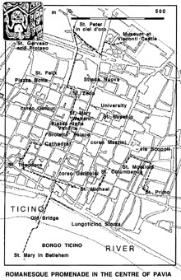
The Romanesque walking itinerary begins in the Castle Archeological Museums where a rich range of sculptures from St. Stephen’s and St. Mary’s churches is preserved. They were the old Twin Cathedrals, demolished to leave space for the present one. In addition, we can find sculptures from St. John’s church demolished to widen Borromeo College in the 19th cent. Here we also have the opportunity to see from a short distance the portals, the façades’ multicoloured decorations and the sculptures with their unfinished particulars.
From the Castle we can reach the nearby St. Peter’s church (12th cent.) whose asymmetrical façade still bears the mark of an old portico. As in every remarkable Romanesque church in Pavia, we can see in the middle of its façade an unusual cross-shaped window between two “eyes”. The nave’s vaults, here as in St. Michael’s, were rebuilt at the end of the 15th cent. with a new technique: in this church maybe to replace a wooden golden ceiling, while in St. Michael’s because the too heavy Romanesque vaults began to fall down. St. Peter’s crypt was remade at the beginning of 1900 during the restoration works followed after a century of decay. In the monument behind the altar, masterpiece of Gothic sculpture, is buried Saint Augustine. In the crypt, in a modern shrine, are preserved Severinus Boethius’ bones and at its back there is a well whose water is told to have ailing properties. As in other sacred places, underground waters influenced the choice where to build a sanctuary. In the nave right to the stairs leading to the altar, we can find King Liutprand’s buring place. He was a wise Longobard legislator.

OOPS! Wat staat daar:
--ailing properties--? Bedoeld is vast en zeker ‘HEALING’
--his BURING place?
Is denkelijk een “vrije vertaling” voor burying place of burial place.

LINK:

ITINERARIES IN PAVIA - http://www.liutprand.it/articoliPavia.asp?id=39.

