Lombardian residence in Corteolona, near Pavia

Corteolona, Oltrepo Pavese, Italy
Built1,200m²
Plot3,000m²
Bedrooms -
Bathrooms -
Year -
Longobardian residence in Corteolona (Pavia province) at 16 km from Pavia, 46 km from Milan and 14 km from the highways Torino-Piacenza and Milan-Naples. The villa is part of a historical hamlet called “Il Castellaro” which the Longobardian King Liutprand (712-744 ac.) had built as his personal residence together with a monastery and a church in honour of S. Anastasius. The Villa was totally restored in 1995, lays on a manicured fenced park of 3.000 m2 and has a living area of 1.200 m2 split over two floors.
Ground Floor: (480 m2) atrium, spacious library, living room with antique chimney, dining room, ample live in kitchen, pantry, laundry, room with a chimney, office and second entrance opened onto a room with professional wood burning oven and 2 bathrooms.
First Floor: (480 m2) 2 mezzanine rooms, 5 large bedrooms, 2 baths (one with double Jacuzzi) and gym. Grand corridor, vestibule, living room with chimney, 2 bedrooms, 1 bathroom, kitchen.
Outdoors: guardian house, garden warehouse, winter garden, 2 garages and a large loggia. Garden with flowerbeds, tall trees and a lovely pond (permission for transforming it into a pool already requested).
Special features: Ideal structure for incoming business (restaurant, conferences, meetings, etc.) Computerized irrigation system with private well and a 2m. high palisade all around.
Photos
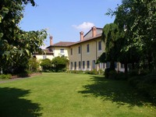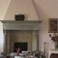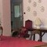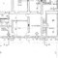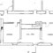
For Sale
EUR 2,000,000
Listing Agent

Giorgio Viganò Real Estate

Milano, Italy

